

Electronic Signature Process
Q-000 xxx
Revision Letter

Revision History
Rev | Status | Date | Author | CO # | Description
A | Draft | 9/10/04 | CB

Training
Role | New | Trained in previous rev.

Purpose
Electronic signatures allow personnel to certify and approve contents of documents and records. Electronic signatures are used because MedCommons personnel are geographically dispersed and the MedCommons document and record control systems are electronic. MedCommons has chosen to use the digital signature capabilities within Adobe Acrobat Standard, which is in compliance with 21 CFR Part 11. (See http://www.adobe.com/support/techdocs/1a546.htm for information from Adobe regarding compliance.)

Scope
This process applies to most MedCommons documents and records. These may include, but are not limited to, documents regarding MedCommons policy, processes, procedures, and records. Procedure-specific automated systems may have their own electronic signature capabilities. If so, the MedCommons documents describing the procedure will describe the capabilities and how they are used.

Responsibilities

Document Coordinator
The Document Coordinator oversees document and record processing. The Document Coordinator ensures that only approved documents are stored in the Released documents folder. Documents requiring additional signatures shall be returned to the author in order to obtain the additional signatures required. The Document Coordinator also provides assistance in creation and distribution of digital IDs and certificates needed to complete electronic signing.

Author
In addition to creating a document requiring approval, it is the author’s responsibility to obtain reviewers’ approvals on the Change Order. The Author certifies the document and the Change Order. Authors distribute digital IDs and certificates for signing documents, as required.

Reviewer/Approver
Once a reviewer has read a draft document and Change Orders commented on correctness and appropriateness, and is satisfied with the resolution of issues, he approves the documents by signing the Change Order. Reviewers distribute digital IDs and certificates for signing documents, as required.

Records created
None

Related Documents

- Q-0002 Document Control

Procedure

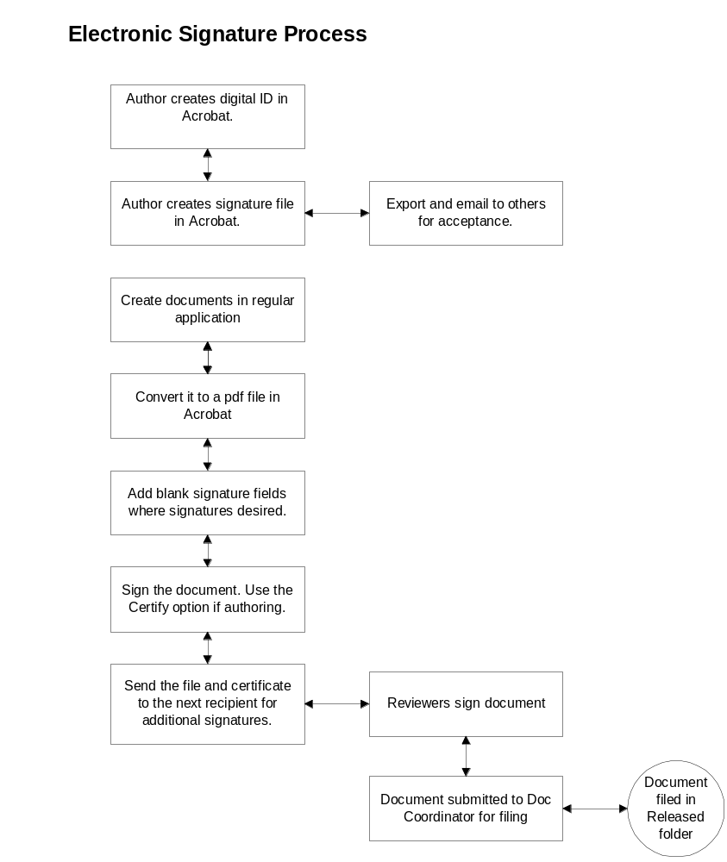

Creating a new digital ID

- From within Adobe Acrobat, select Manage my Digital ID
- Select Advanced>>Manage Digital IDs>>My Digital ID.
- Click Add.
- Click Self-signed Digital ID>>Continue.
- Fill in all fields. Click Create.
- A security warning will appear. Click Yes to install the certificate.
- You will then need to export the certificate and email it to the Document Control Coordinator and others who will review the document. Highlight the certificate in the list and click Export.
- Click the Save the Data to a File radio button, then Next.
- Save the file to your disk. Be sure to remember where you saved it.
- Close the window. You now have a valid certificate, which you will need to share with others on your reviewing list. These people will need to import this certificate in order to see signatures and verify that they are valid.

Creating a document that will be certified

- Create the document in Word (or other application) and edit until finished. This step includes gathering input from all reviewers.
- Include a space for the electronic signature field to appear under the Revision History Table on the cover page.
- Convert the document to a pdf file in Acrobat Standard. (See instructions below.)
- Sign the document, using the Certify option.
- Send the file and your certificate to the next recipient for additional signatures.

Creating a change order (or other record) that will be signed by reviewers.
  - Create the record in Word (or other application) and edit until finished.
  - If the template does not already have one, include a space for your certification and one for each of the reviewer’s signatures.
  - Convert the record to a pdf file in Acrobat Standard. (See instructions below.)
  - Create an electronic signature field for each reviewer.
  - Certify the record in the certification field. When asked to select actions allowed, select “Allow only forms fill-in actions.” (Note that selecting “Disallow any changes” will prevent the next signer from signing the document.)
  - Send the file to the next recipient for his signature.

Converting a document to a .pdf file

- Open the file to be converted in Acrobat.
- Select File>Create pdf from a file>browse to file.
- Click Open and wait until the conversion is completed.
- Alternately, you can use the Adobe menu in Word (if present) to convert the file.

Certifying a document (Author)
- Within Acrobat, click Sign>> Sign this document. An alert appears saying that the document is not certified. You should certify it. (Note that if you certify first, and then make any changes, it invalidates the certification. Do not do this!)
- On the Save as Certified Document dialog, click OK.
- Select Allowed actions: “Disallow any changes.”

- Click Next. Show Certification on document.
- Click Next. Mouse click/drag to show where your certified signature goes.
- Digital ID selection window – select your ID from list. If there is none there, click Add ID, and browse to find one or create a new self-signed one.
- Click OK. Add Reason for signing, and fill in other fields.
- Click Sign and save. You will get a dialog saying that you have successfully signed. Click OK.

Signing a document (Reviewer)
- Open the pdf file.
- Click the Sign button.
- Select Sign this document.
- Click the blank signature field where your signature will be displayed.
- Select a digital ID.
- On the Apply signature to document dialog, fill in all fields, including the reason for signing.
- Click Sign and Save. A dialog will appear saying that you have successfully signed this document.
- Email the document to next reviewer and notify the author that you have signed.

